**栏目设置：About Research News Members**

**About**

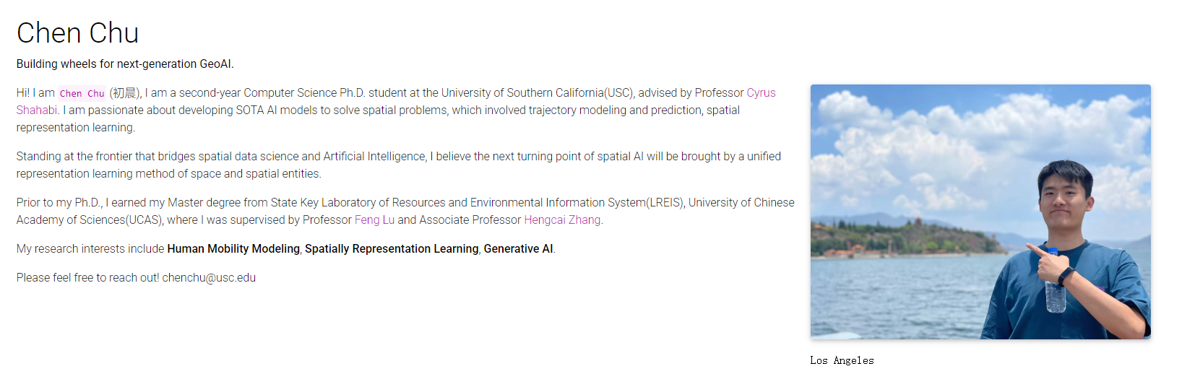

Dr. Rui Jing

Hi! I am an Associate Professor in College of Energy, Xiamen University and World's Top 2% Scientists (2022~2025). My research focuses on urban building energy modelling, multi-energy system optimization, demand-side management, climate resilience & nexus.

Before, I used to study and work in Imperial College London (2018~2019), Chinese Academy of Science (2019~2021), and Cardiff University (2021~2022). So far, I have co-authored more than 90 publications in international journals and book chapters. See Google Scholar.

（只需链接到我的谷歌学术）

https://scholar.google.com/citations?user=zXvQJ4oAAAAJ&hl=zh-CN&oi=sra

Collaboration is warmly welcomed!

Contact: rjing@xmu.edu.cn

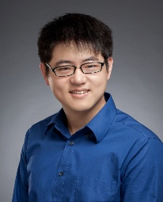

**Research Focuses**

**1 Urban Building Energy Modelling (UBEM)**

We develop physical based UBEM for 330 cities of China, covering 40,000,000 buildings across the country. It serves as a Sand Table to evaluate distributed PV potential, building retrofit performance, and building-to-grid flexibility.

[这里放一个视频，我单独发你]

**2 Multi-energy system modelling & optimization**

From building-community-city scale multi-energy system modelling & optimization, including multi-objectives, handling uncertainties, multi-node energy transfer, AI-informed optimization

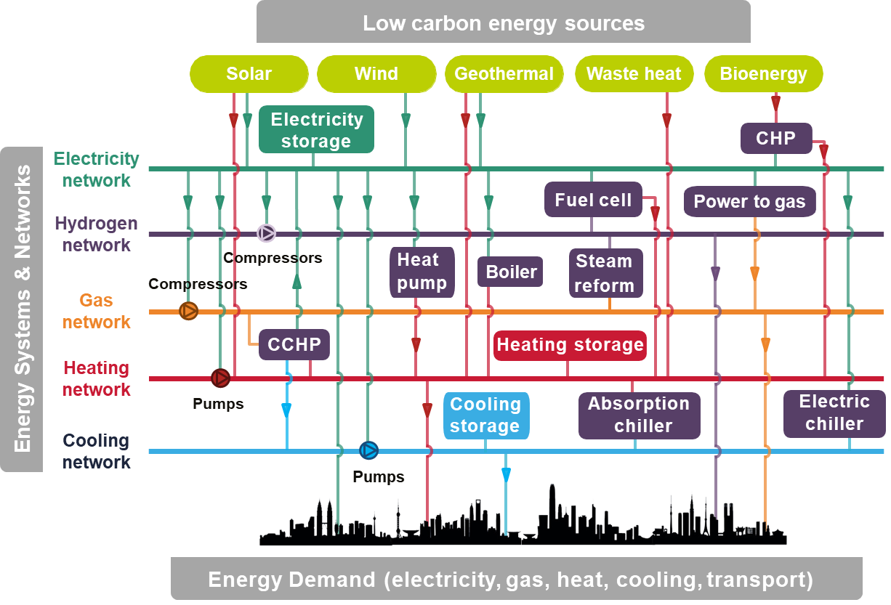

**3 Demand-side management**

We collaborate with industrial partner to develop demand-side management platform aiming for decarbonization of a building or an industrial park. Key technologies: Supply-demand forecasting, facility status monitoring, and LLM enabled system operation.

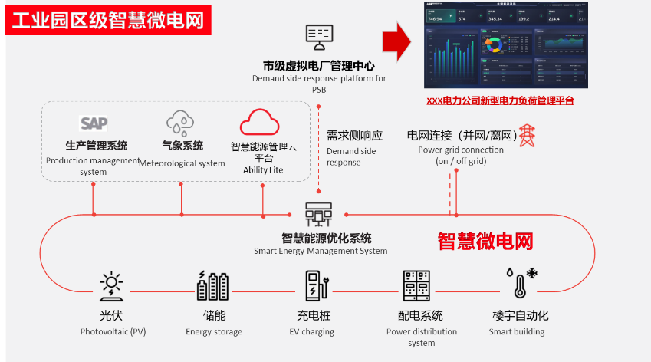

**4 Climate resilience & nexus**

We generate high-resolution urban climate (1km/1h) to analyze its impact on energy use. Meanwhile, we simulate typhoon to analyze its impact on wind power generation. We also analyze future climate change impact on building energy use.

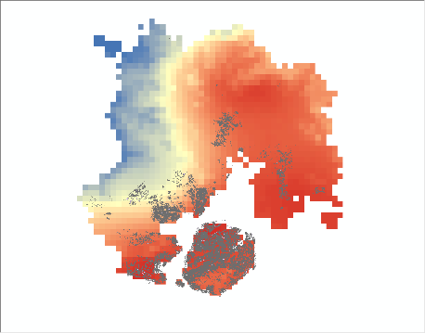 

**News**

Greetings to Yaqiu Xiao, she published on **Applied Energy** as a second-year master student.

Title: Interpretable short-term electricity load forecasting considering small sample heatwaves

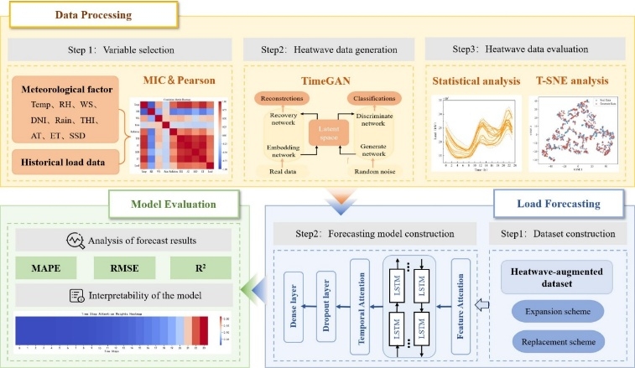

Greetings to Xinle Hu, he published on **Applied Energy** as a second-year master student.

Stochastic optimal design of integrated energy systems considering seismic hazards

图片1张（预留一下）

Greetings to Mr. Qihan Wu, his paper has been selected as **Best Paper at ECE2024**

Distributionally robust optimization for multi-hub interconnected integrated energy systems capturing renewable uncertainties

图片1张（预留一下）

**Members**

**Graduate Students**

Yaqiu Xiao

Her research focuses on small sample and interpretable demand prediction during summer heatwaves.

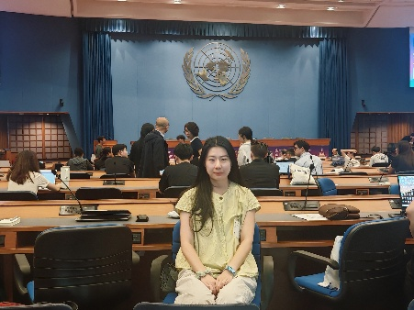

Xinle Hu

His research focuses on modelling and optimization of urban energy systems enhancing earthquake resilience.

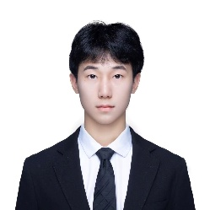

Xianjie Liu

His research focuses on modelling and optimization of urban heating networks incorporating Game Theory.

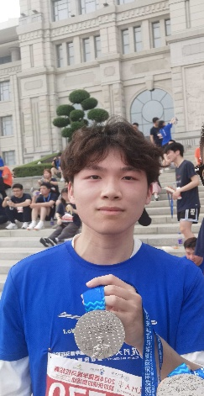

Qihan Wu

His research focuses on distributed robust + stochastic optimization of urban energy systems considering long-short uncertainties. [Visiting student]

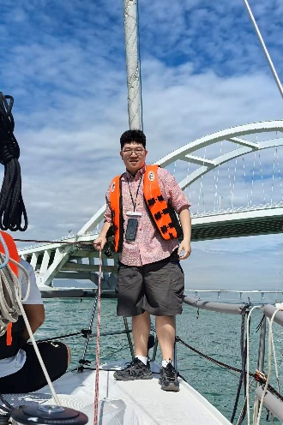

Zhijia Zhu

His research focuses on distributed robust optimization of urban energy systems considering Typhoon and wave co-impact. [Visiting student]

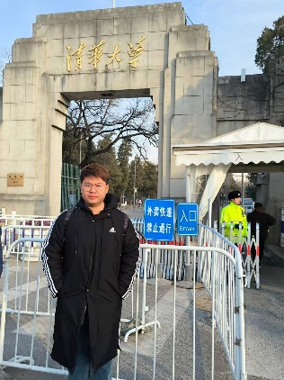

Yue Tang

Her research focuses on LLM enhanced demand prediction during summer heatwaves.



Na Lv

Her research focuses on distributed robust optimization of multi-node energy systems. [Visiting student]



Mengyang Wang

Her research focuses on supply-demand multi-task prediction. [Visiting student]

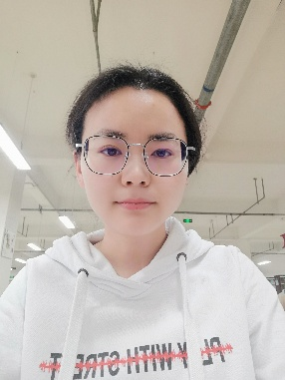

Wenye Yu

His research focuses on offshore wind-powered energy systems considering transport and long-short energy storage.

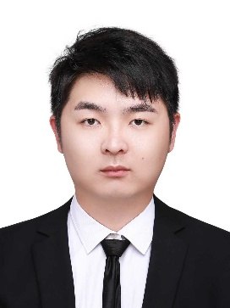

Guangchen Long

His research focuses on PV/T system design optimization and thermal dynamics.

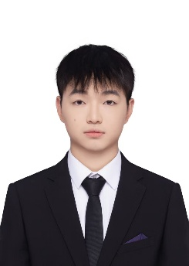

Kairui Liu

Her research focuses on retrofitting fire water pool into cooling storage tank and cost-benefit assessment.

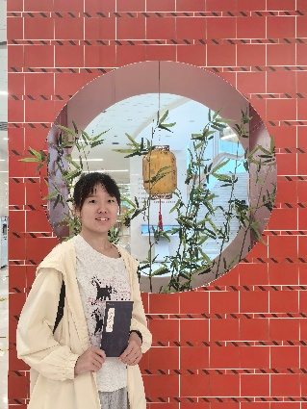

Zirui He

Her research focuses on data driven fire disaster risk assessment from building-energy-human aspects.

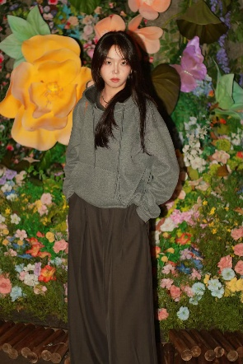

Minghao Deng

His research focuses on climate change impact on energy demand and sleep disruption.

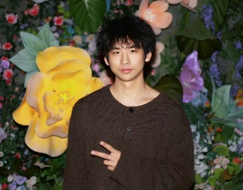

Wangjun Xiong

His research focuses on LLM enabled optimal dispatch of multi-energy systems.

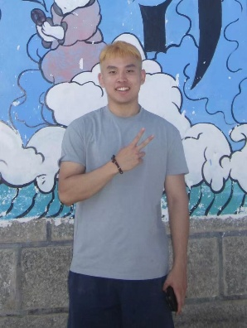

Chentao Yang

His research focuses on planning multi-energy integrated power base considering extreme weather.

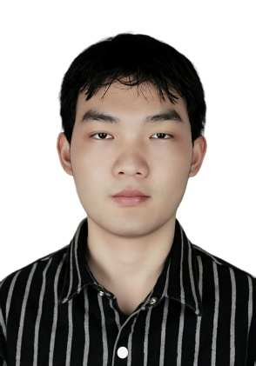

Yubo Wang

His research focuses on of using PV+battery for decarbonizing highway operation across China. [Visiting student]

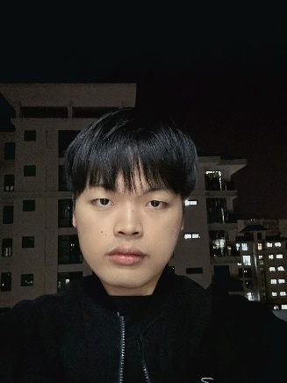

**Undergraduates**

Entong Lin

Her research focuses on urban distributed PV potential and utilization challenge

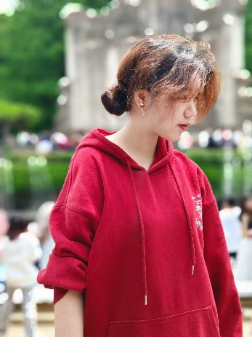

Lin Luo

His research focuses on design optimization of multi-energy systems.

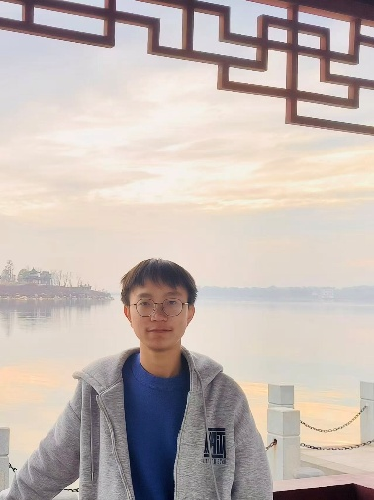

Hao Yu

His research focuses on design optimization of multi-energy systems.

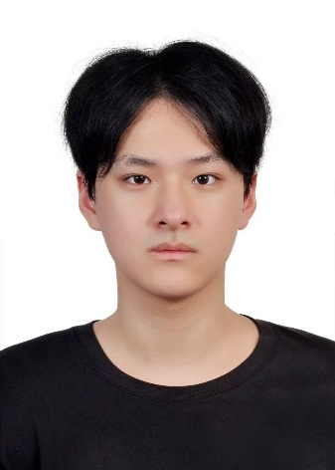

**Technical experts**

**Dr. Meng Wang**

He is an expert in urban building energy modelling & we have collaborated for more than 10 years.

**Ze Wang**

He is an expert in data processing and LLM applications.

（照片位置，预留一下）

**Jiahao Wan**

He is an expert in GIS and data analytics.

（照片位置，预留一下）

**Duo Qi**

He is an expert in GIS and data acquisition.

（照片位置，预留一下）

**Xiaotong Ouyang**

She is an expert in GIS and data analytics.

（照片位置，预留一下）